**Electric Vehicles Market Segmentation**

--Market Segmentation in India

*BY*

PUPPALA SAITEJA

*Abstract*

The electric vehicle (EV) market in India is experiencing rapid growth, driven by the country’s commitment to reducing carbon emissions and promoting sustainable mobility. This study aims to analyze the market segmentation of EVs in India based on demographic, geographic, behavioral, and psychographic factors.

**Demographic segmentation:** reveals that younger consumers, particularly those aged 25-40, are more inclined towards EV adoption due to their environmental consciousness and technological savvies. Higher income groups also show a greater propensity to purchase EVs, driven by their ability to afford the higher upfront costs.

**Geographic segmentation:** indicates that urban areas, especially metropolitan cities like Delhi, Mumbai, and Bangalore, are the primary markets for EVs. These regions benefit from better charging infrastructure and government incentives, making EV adoption more feasible.

**Behavioral segmentation:** highlights that early adopters and environmentally conscious consumers are the key drivers of the EV market. These consumers prioritize sustainability and are willing to pay a premium for eco-friendly transportation options. Additionally, fleet operators and businesses are increasingly adopting EVs for their lower operating costs and compliance with environmental regulations.

**Psychographic segmentation:** shows that consumers with a strong preference for innovation and technology are more likely to purchase EVs. These consumers value the advanced features and connectivity options offered by modern EVs. Moreover, the desire to reduce carbon footprints and contribute to a cleaner environment significantly influences their purchasing decisions.

The study concludes that targeted marketing strategies focusing on these segments can enhance EV adoption in India. Visualizations and data-driven insights are essential to support these strategies and drive the growth of the EV market.

**Data Collection Sources:**

Data has been collected manually from the below sources

* Kaggle: <https://www.kaggle.com/>
* **Data.gov.in:** <https://data.gov.in/>

TARGET SEGMENTATION

The primary problem statement in EV vehicle market segmentation is to identify distinct groups of consumers with unique needs, preferences, and behaviours to effectively target marketing efforts and product development.

* **Understand consumer preferences:** Identify the factors that influence EV purchase decisions, such as range, price, charging infrastructure, and features.
* **Segment the market:** Group consumers into distinct segments based on these preferences and characteristics.
* **Tailor marketing strategies:** Develop targeted marketing campaigns and product offerings for each segment.
* **Optimize resource allocation:** Allocate resources effectively to maximize market penetration and profitability.

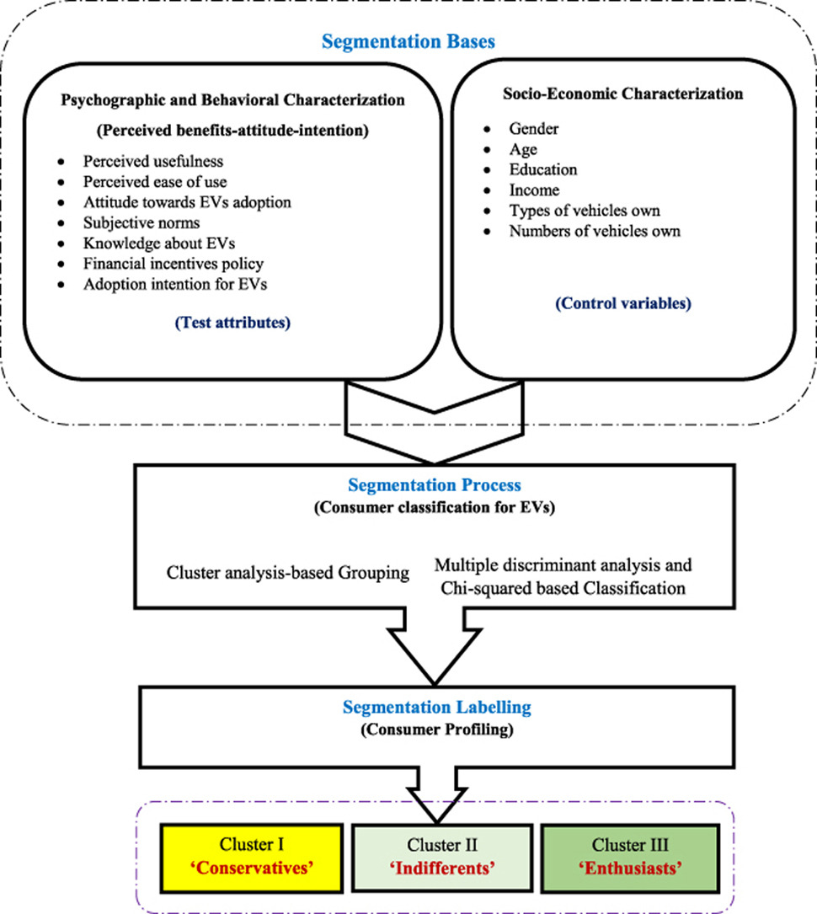

**Psychographic and Behavioural Characterization:**

* **Perceived benefits:** How consumers perceive the benefits of EVs (e.g., environmental friendliness, cost savings, technology adoption).
* **Attitude towards EVs:** Consumer attitudes and beliefs about EVs.
* **Subjective norms:** Social and cultural influences on EV adoption decisions.
* **Knowledge about EVs:** Consumer awareness and understanding of EV technology.
* **Financial incentives policy:** Government policies and incentives that encourage EV adoption.
* **Adoption intention:** Consumer intentions to purchase an EV in the future.

**Socio-Economic Characterization:**

* **Gender:** Gender differences in EV adoption preferences.
* **Age:** Age-related factors influencing EV purchase decisions.
* **Education:** Educational level and its impact on EV adoption.
* **Income:** Income level and its correlation with EV affordability.
* **Types of vehicles owned:** Current vehicle ownership and its influence on EV adoption.
* **Number of vehicles owned:** Household size and its impact on EV needs.

**Segmentation Process:**

* **Cluster analysis-based grouping:** Grouping consumers based on similarities in their psychographic and socio-economic characteristics.
* **Multiple discriminant analysis and Chi-squared based classification:** Applying statistical techniques to identify distinct consumer segments.
* **Segmentation labeling:** Assigning labels to each segment based on their unique characteristics (e.g., "Conservatives," "Indifferent," "Enthusiasts")

**Implementation**

**Packages/Tools Used:**

1. **Numpy:** To calculate various calculations related to Arrays.
2. **Pandas:** To load or read the datasets.
3. **Matplotlib:** Matplotlib is a powerful and widely-used plotting library in Python, designed for creating static, animated, and interactive visualizations
4. **Seaborn:** It provides a high-level interface for creating attractive and informative statistical graphics.

**Behavioural Market Segmentation**

**Data cleaning for ElectricCarData_Clean**

Data cleaning is a crucial step in any data analysis process. It involves preparing your data by addressing issues such as missing values, outliers, duplicates. Here are some common steps and techniques for data cleaning using Python, primarily leveraging the **Pandas** and **NumPy** libraries.

1. Loading Data
2. Handling Missing Value
3. Removing Duplicates

### Handling Outliers

### Standardizing Data

### Data Type Conversion

### Screenshot 2024-09-17 191117.pngSaving Cleaned Data

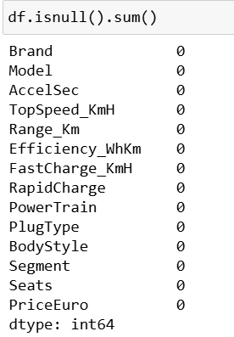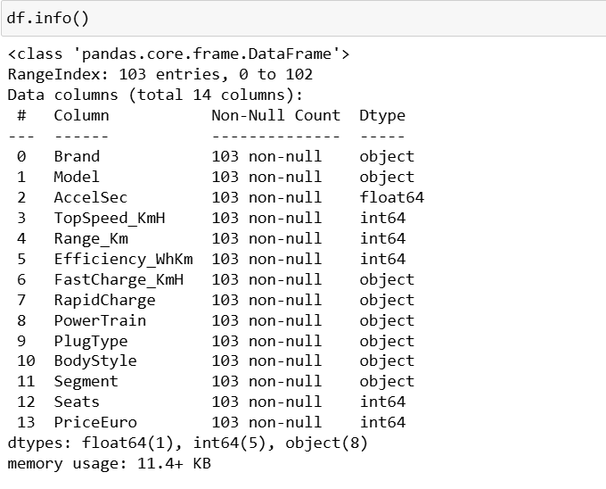

**Data Visualization for ElectricCarData_Clean**

Data visualization is a powerful way to represent data graphically, making it easier to understand patterns, trends, and outliers. Here are some key aspects and tools for data visualization.

**Visualization of data using Python libraries**

**Acceleration of cars according to their Brands**

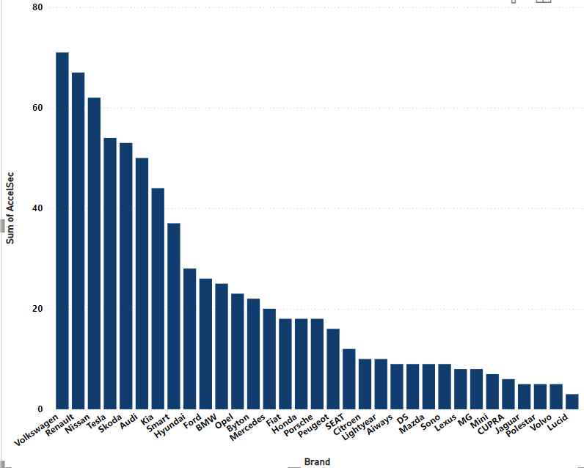

**Observations:**

* **Tesla:** The chart suggests that Tesla vehicles exhibit the highest acceleration performance, with a significantly higher "Sum of AccelSec" compared to other brands.
* **Volkswagen, Renault and Nissan:** These brands also demonstrate strong acceleration capabilities, ranking high in the chart.
* **Mid-Range Brands:** Brands like Skoda, Audi, Kia, and Hyundai show moderate acceleration performance.
* **Lower-Tier Brands:** Brands like Fiat, Peugeot, Citroen, and MG exhibit lower acceleration figures.

**Conclusion:**

Based on the data presented in the chart, it appears that Tesla and a few other brands have a significant advantage in terms of acceleration performance

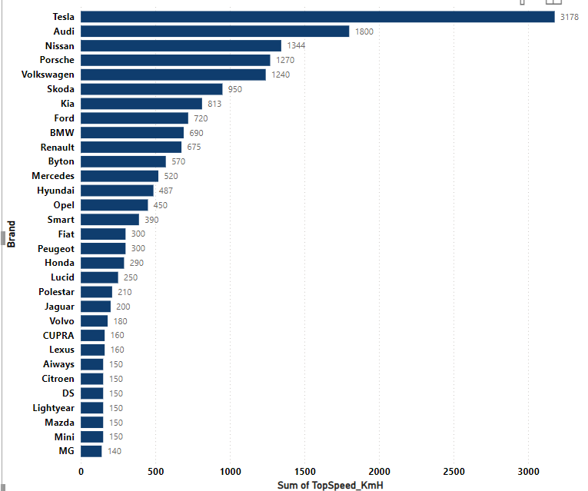**Top speed of cars according to their Brands**

**Observations:**

* **Tesla:** Tesla stands out with the highest "Sum of TopSpeed_KmH," suggesting it has models with the highest top speeds among the listed brands.
* **German Brands:** Several German brands, such as Audi, Nissan, Porsche, and Volkswagen, also demonstrate strong top speeds.
* **Mid-Range Brands:** Brands like Kia, Ford, and Renault occupy the middle ground in terms of top speed.
* **Lower-Tier Brands:** Brands like Fiat, Peugeot, Citroen, and MG generally have lower top speeds.

**Conclusion:**

Based on the data presented in the chart, Tesla appears to have a significant advantage in terms of top speed compared to other brands.

**Price segmentation according to Brand**

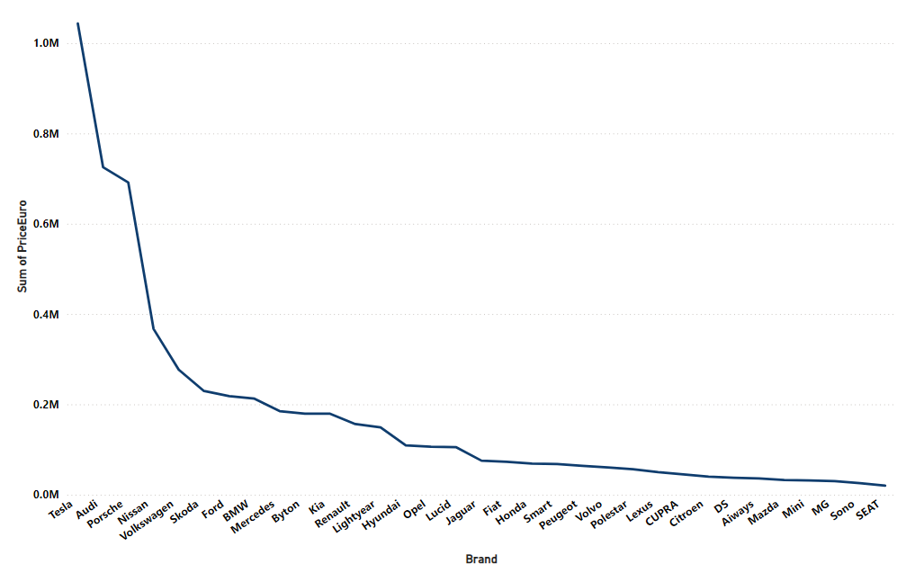

**Observations:**

* **Tesla:** Tesla stands out with the highest "Sum of PriceEuro," suggesting its vehicles are generally more expensive compared to other brands.
* **German Brands:** Several German brands, such as Audi, Porsche, and Volkswagen, also have high price tags.
* **Mid-Range Brands:** Brands like Kia, Ford, and Renault occupy the middle ground in terms of pricing.
* **Lower-Tier Brands:** Brands like Fiat, Peugeot, Citroen, and MG generally have lower prices.

**Conclusion:**

Based on the data presented in the chart, it appears that Tesla and several German brands are positioned in the premium segment, while other brands offer more affordable options.

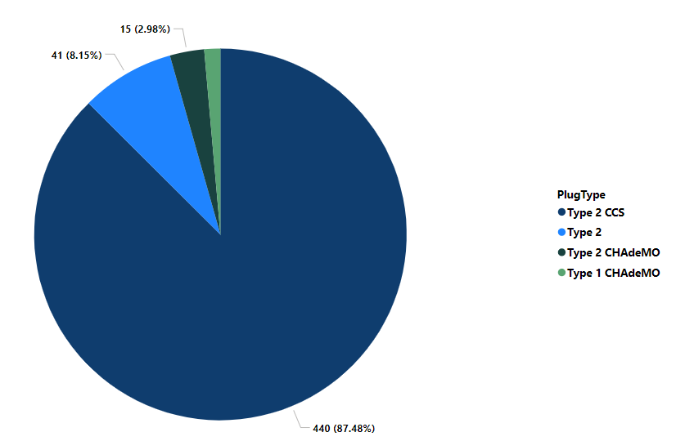**Acceleration segmentation according to Plug type of cars**

**Observations:**

* **Type 2 CCS:** This plug type dominates the market, accounting for 83.96% of the total.
* **Type 2:** The second most common plug type, representing 11.21% of EVs.
* **Type 2 CHAdeMO:** A smaller segment, comprising 7.95% of EVs.
* **Type 1 CHAdeMO:** The least common plug type, with only 1.83% of EVs using it.

**Conclusion:**

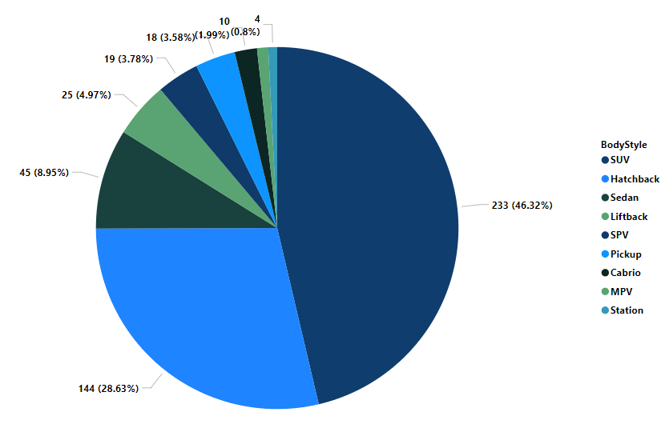Based on the pie chart, Type 2 CCS is the most prevalent plug type for electric vehicles in the given dataset. This suggests that charging infrastructure and vehicle manufacturers are favoring this standard. However, the presence of other plug types indicates a degree of diversity and competition in the market.

**Number of seats according to plug type of cars**

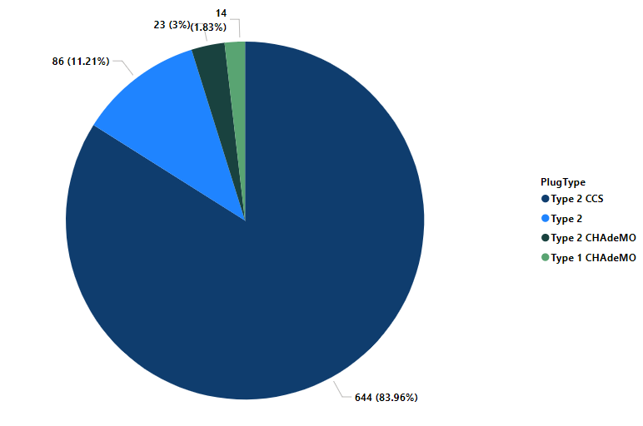**Observations:**

* **Type 2 CCS:** This plug type dominates the market, accounting for 87.48% of the total seats.
* **Type 2:** The second most common plug type, representing 8.15% of seats.
* **Type 2 CHAdeMO:** A smaller segment, comprising 2.98% of seats.
* **Type 1 CHAdeMO:** The least common plug type, with only 1.83% of seats.

**Conclusion:**

Based on the pie chart, it appears that the majority of EVs with Type 2 CCS connectors have a higher number of seats compared to other plug types. This could suggest that Type 2 CCS is more commonly used in larger vehicles or those designed for family or commercial use

**Number of seats according to their body style**

**Observations:**

* **Sedan:** The most common body style, accounting for 46.32% of seats.
* **Hatchback:** The second most common body style, representing 28.63% of seats.
* **SUV:** A significant segment, comprising 8.95% of seats.
* **Pickup:** A smaller segment, accounting for 4.97% of seats.
* **MPV:** Another relatively small segment, with 3.78% of seats.
* **Cabrio, Station, Liftback:** These body styles have a much smaller presence, each accounting for less than 5% of seats.

**Conclusion:**

Based on the pie chart, sedan and hatchback body styles are the most prevalent in terms of passenger capacity. SUVs, while less common, still represent a significant portion of the market. Other body styles, such as pickup, MPV, and convertible, have a smaller share of seats.

**Applying k means clustering for Data**

K-means clustering is a popular unsupervised machine learning algorithm used to partition a dataset into distinct groups or clusters. Here are the key steps involved in the K-means clustering process:

1. **Initialization:**

* Choose the number of clusters, ( k ).
* Randomly select ( k ) initial centroids from the dataset.

1. **Assignment:**

* Assign each data point to the nearest centroid based on the Euclidean distance. This forms ( k ) clusters.

1. **Update**:

* Calculate the new centroids by taking the mean of all data points assigned to each cluster.

1. **Iteration**:

* Repeat the assignment and update steps until the centroids no longer change significantly or a maximum number of iterations is reached.

1. **Convergence**:

* The algorithm converges when the centroids stabilize, meaning the clusters do not change significantly with further iterations.

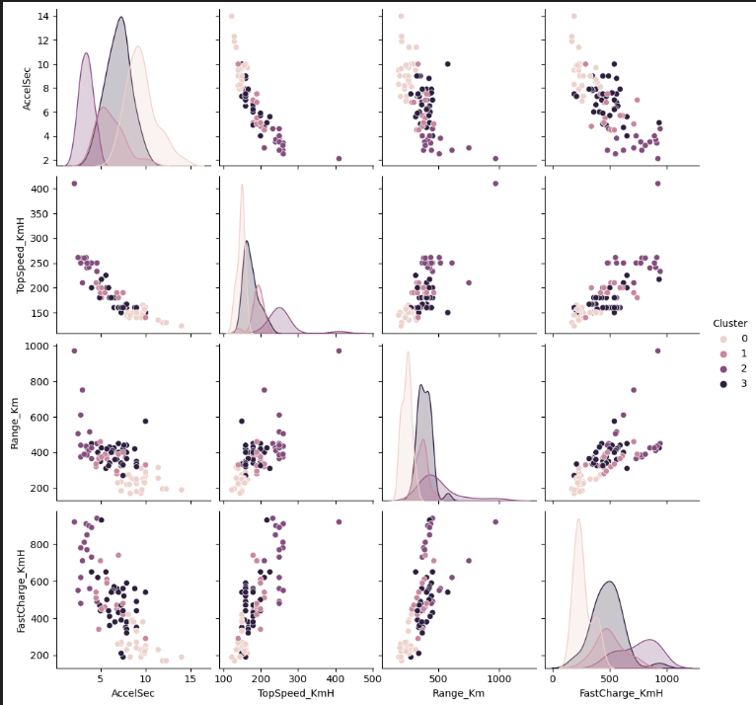

**Conclusions:**

* Based on the clustering results, it appears that the electric vehicles can be grouped into four distinct segments based on their performance characteristics.
* The relationships between variables suggest that certain combinations of acceleration, top speed, range, and fast charging capabilities are more common.
* Further analysis could delve into the specific characteristics of each cluster to understand the factors driving the segmentation.

**Additional Insights:**

* **Cluster 0:** This cluster appears to be characterized by higher acceleration and top speed, but potentially lower range and fast charging capabilities.
* **Cluster 1:** This cluster might represent vehicles with a good balance of acceleration, top speed, and range, but possibly lower fast charging capabilities.
* **Cluster 2:** This cluster could be associated with vehicles that prioritize range and fast charging over acceleration and top speed.
* **Cluster 3:** This cluster might represent vehicles with a focus on range and efficiency, possibly sacrificing acceleration and top speed.

**Demographic and Socioeconomic Market Segmentation**

**Data Visualization for Indian automobile buying behavior study**

**Insights from the Age Distribution of Car Buyers Histogram**

### Screenshot 2024-09-21 114128.png

### ****Key Observations:****

* **Bimodal Distribution:** The histogram indicates a bimodal distribution, suggesting two distinct peaks in the age distribution of car buyers.
* **First Peak (Younger Age Group):** The first peak appears to be around the age of 25-30. This suggests a significant portion of car buyers are younger individuals, possibly first-time buyers or those entering the workforce.
* **Second Peak (Older Age Group):** The second peak is around the age of 35-40. This indicates a substantial number of car buyers in this age group, possibly those seeking upgrades or replacing older vehicles.
* **Decreasing Frequency:** The frequency of car buyers decreases after the second peak, suggesting a lower proportion of buyers in older age groups.

**Conclusions:**

* **Targeted Marketing:** The bimodal distribution suggests that car manufacturers can effectively target two distinct age groups with different marketing strategies.
* **Product Offerings:** Understanding these age groups can help tailor product offerings to meet their specific needs and preferences.
* **Financial Planning:** The data can inform financial institutions about the potential demand for car loans and insurance products in these age groups.
* **Policy Implications:** Government agencies can use this information to plan for infrastructure development, transportation policies, and incentives for car purchases.

**Insights from the Profession Distribution of Car Buyers Histogram**

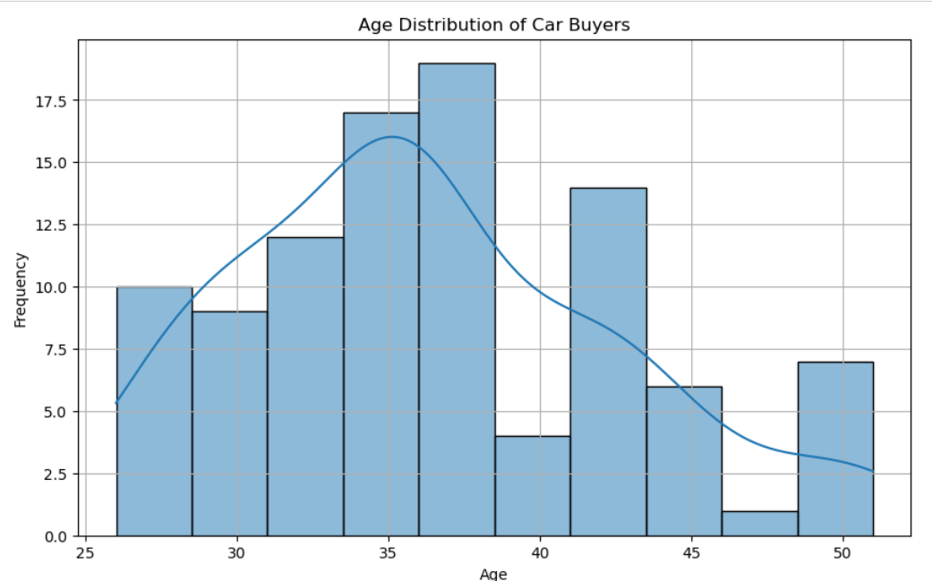

**Key Observations:**

* **Dominance of Salaried Individuals:** The bar chart clearly shows that a significantly higher number of car buyers belong to the "Salaried" profession compared to "Business."
* **Smaller Proportion of Business Owners:** While the "Business" category represents a considerable portion of car buyers, it is notably smaller than the "Salaried" category.

**Conclusions:**

* **Targeted Marketing:** Car manufacturers can focus their marketing efforts primarily on salaried individuals, who constitute the majority of car buyers.
* **Product Offerings:** Understanding the dominant profession can help tailor product offerings to meet the specific needs and preferences of salaried individuals.
* **Financial Services:** Financial institutions can tailor their loan and insurance products to cater to the financial profiles of salaried individuals.
* **Policy Implications:** Government policies related to car ownership and taxation can be designed with a focus on salaried individuals.

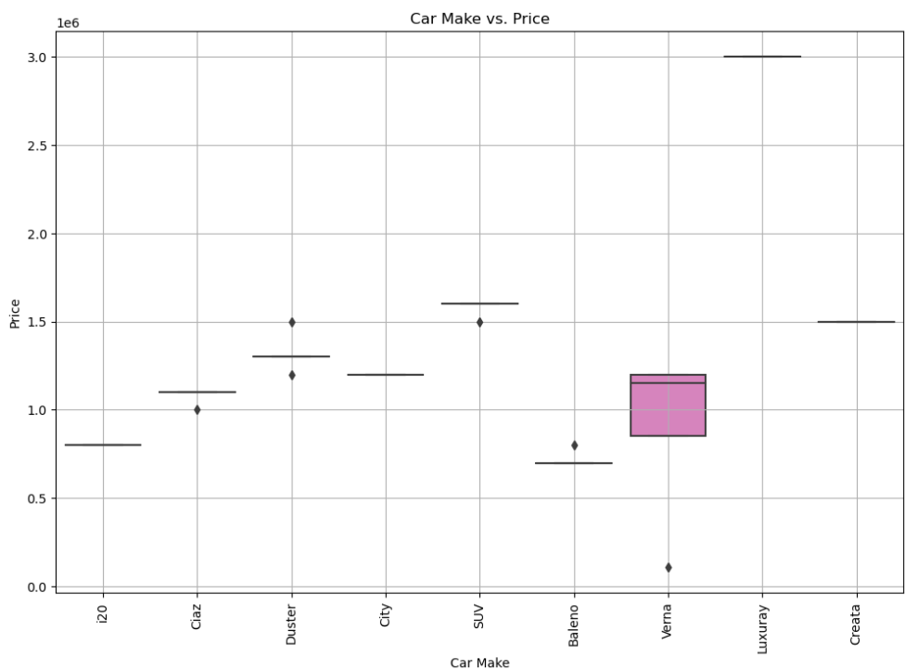**Insights from the Car Make vs. Price Box Plot**

**Key Observations:**

* **Price Distribution:** The box plots illustrate the distribution of car prices for each car make. The height of the box represents the interquartile range (IQR), indicating the spread of the middle 50% of the data. The whiskers extend to the minimum and maximum values, excluding outliers.
* **Outliers:** The individual points outside the whiskers represent outliers, which are data points that are significantly different from the rest of the data.
* **Median Prices:** The horizontal line within each box represents the median price for that car make.
* **Price Overlap:** There is some overlap between the price distributions of different car makes, suggesting that price is not solely determined by the brand.

**Conclusions:**

* **Price Variation:** The box plots show that there is significant variation in prices within each car make. This indicates that factors other than the brand, such as model, features, and options, influence the price.
* **Luxury Brands:** The "Luxury" segment appears to have the highest median price and a wider range of prices, suggesting it includes models with premium features and higher price tags.
* **Mid-Range Brands:** Brands like Ciaz, Duster, City, and Verna have a more concentrated price distribution, indicating less variation in prices within these segments.
* **Budget-Friendly Brands:** Brands like Baleno and Creta have lower median prices and a narrower range of prices, suggesting they are positioned in the budget-friendly segment.

**Insights from the Pair Plot: K-Means Clustering of Car Buyers**

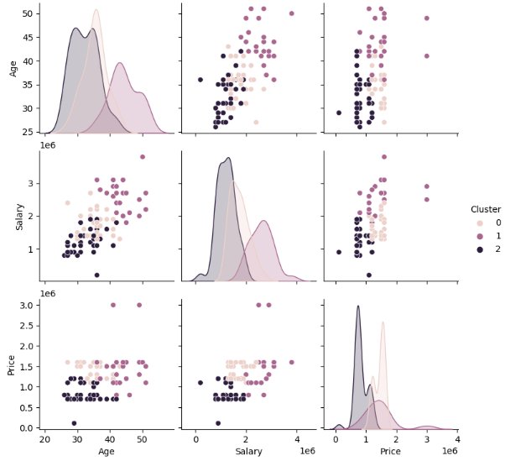

**Key Observations:**

* **Clustering:** The plot clearly shows three distinct clusters, suggesting that the data points can be naturally grouped into these three categories.
* **Relationships between Variables:** The scatter plots within the matrix reveal relationships between the variables. For example, there appears to be a positive correlation between age and salary, indicating that older individuals tend to have higher salaries.
* **Density Plots:** The diagonal plots show the distribution of each variable. This helps visualize the range and concentration of values for each variable.

**Conclusions:**

* **Based on the clustering results, it appears that the car buyers can be segmented into three distinct groups based on their age, salary, and price preferences.**
* **Cluster 0:** This cluster might represent younger buyers with lower salaries and a preference for more affordable cars.
* **Cluster 1:** This cluster could be associated with mid-aged buyers with higher salaries and a willingness to spend more on cars.
* **Cluster 2:** This cluster might represent older buyers with established incomes and a preference for luxury or premium cars.

**Geographic Market Segmentation**

**Electric vehicle (EV) charging stations in India**

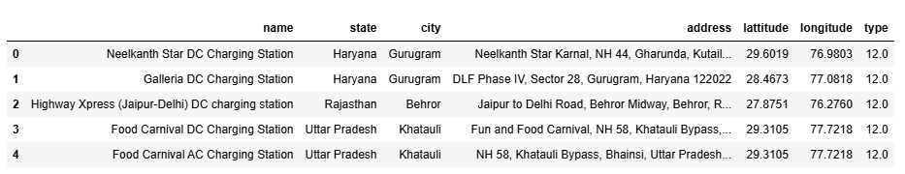

**Key Observations:**

* **Geographic Distribution:** The charging stations are located in multiple states, including Haryana, Rajasthan, and Uttar Pradesh.
* **Urban Concentration:** Many stations are located in cities, particularly Gurugram.
* **Highway Locations:** Some stations are situated along highways, suggesting a focus on long-distance travel.
* **Variety of Types:** Both DC and AC charging stations are represented, indicating a mix of charging capabilities.

**Potential Analysis:**

* **Geographic Density:** Analyze the density of charging stations in different regions to identify areas with adequate or insufficient infrastructure.
* **Charging Type Distribution:** Evaluate the distribution of DC and AC charging stations to understand the prevailing charging standards.
* **Accessibility:** Assess the accessibility of charging stations, considering factors like proximity to residential areas, commercial centers, and highways.
* **Charging Capacity:** Gather information about the charging capacity of each station to evaluate their ability to handle demand.
* **Network Connectivity:** Explore the integration of charging stations with different networks or platforms for seamless user experience.

**Number of EV Charging Stations by State:**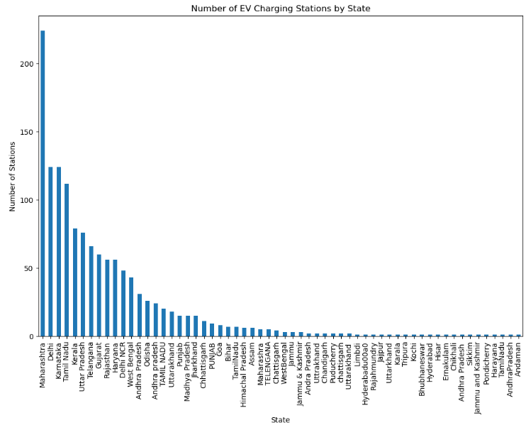

**Key Observations:**

* **Maharashtra Dominance:** Maharashtra leads with the highest number of EV charging stations, indicating a strong focus on EV infrastructure development in the state.
* **Delhi and Karnataka:** Delhi and Karnataka follow closely behind, suggesting a growing emphasis on electric mobility in these regions.
* **Regional Disparities:** There are significant disparities in the distribution of charging stations across Indian states. States like Maharashtra, Delhi, and Karnataka have a much higher concentration compared to others.
* **Emerging Markets:** States like Tamil Nadu, Telangana, and Rajasthan are emerging as key markets for EV adoption, with a growing number of charging stations
* **Smaller States:** States like Sikkim, Andaman & Nicobar Islands, and Pondicherry have a limited number of charging stations, suggesting potential challenges for EV adoption in these regions.

**Top 10 Cities with Most EV Charging Stations:**

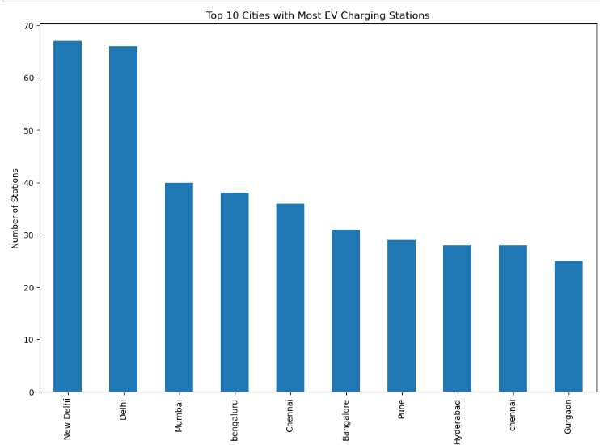

**Key Observations:**

* **New Delhi Dominance:** New Delhi stands out as the city with the highest number of EV charging stations, indicating a strong focus on electric mobility infrastructure in the capital.
* **Metropolitan Cities:** Other major metropolitan cities like Delhi, Mumbai, Bangalore, and Chennai also have a significant number of charging stations, reflecting a growing demand for EVs in these urban areas.
* **Tier-2 Cities:** Cities like Pune, Hyderabad, and Gurgaon also feature prominently in the top 10, suggesting a growing trend of EV adoption in these regions.
* **Regional Disparities:** The concentration of charging stations in a few major cities highlights the need for more equitable distribution across India.

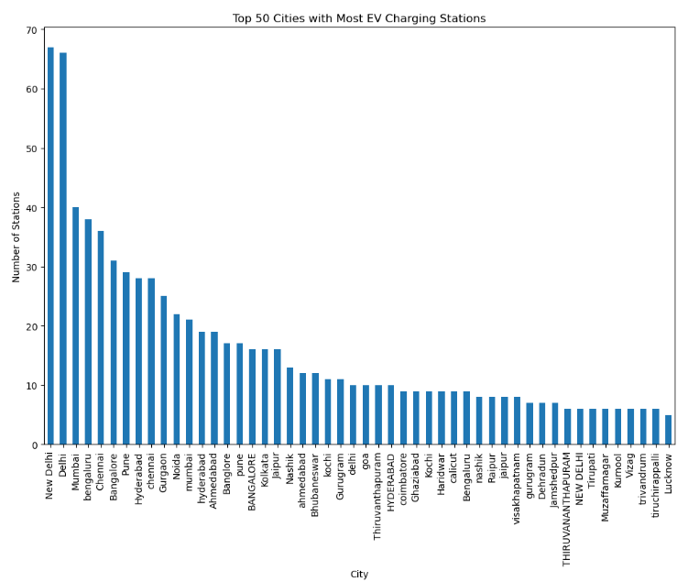**Top 50 Cities with Most EV Charging Stations:**

**Key Observations:**

* **New Delhi Dominance:** New Delhi stands out as the city with the highest number of EV charging stations, indicating a strong focus on electric mobility infrastructure in the capital.
* **Metropolitan Cities:** Other major metropolitan cities like Delhi, Mumbai, Bangalore, and Chennai also have a significant number of charging stations, reflecting a growing demand for EVs in these urban areas.
* **Tier-2 Cities:** Cities like Pune, Hyderabad, and Gurgaon feature prominently in the top 10, suggesting a growing trend of EV adoption in these regions.
* **Regional Disparities:** There are significant disparities in the distribution of charging stations across Indian states. States like Maharashtra, Delhi, and Karnataka have a much higher concentration compared to others.
* **Concentration in Southern States:** Cities in the southern states, such as Bangalore, Chennai, and Hyderabad, have a relatively strong presence in the top 50, indicating growing EV adoption in these regions.

**Conclusions:**

* **Targeted Market Segmentation:** The data suggests that geographical segmentation is crucial for the EV market in India. Different regions have varying levels of EV adoption and infrastructure development.
* **Urban Focus:** Targeting major cities like (New Delhi, Delhi, Mumbai, Bangalore, Chennai, Pune, Hyderabad, Chennai, and Gurgaon) with a high concentration of charging stations can be a strategic approach for EV manufacturers and service providers.
* **Regional Expansion:** Identifying regions with growth potential can help guide future investments in charging infrastructure and marketing efforts.
* **Policy Support:** Government policies can play a vital role in promoting EV adoption in different regions by providing incentives, subsidies, and infrastructure development.

**Solution for the Problem:**

**Behavioural**

* By the behavioural analysis we can find that the 5 seater cars are sold high and plug type 2 ccs is considered by maximum people.
* Most of the customers are considering the cars with features like Top Speed and Acceleration.
* Most of the customers who buys cars are Between the age of 30 to 45 so we can target the location with these age.
* These cars are purchased by salaried Peoples.

**Psychographic Segmentation**

* The high priced like Volkswagen, Renault, Nissan, Tesla, Audi, Bmw, Ford and Tesla are more likely considered.
* They are made with high safety and Durability.
* These cars are purchased by Business Magnets.

**Geographical Segmentation**

* The geographical segmentation is done according to the EV stations present in India.
* Maharashtra leads with the highest number of EV charging stations, indicating a strong focus on EV infrastructure development in the state.
* States like Tamil Nadu, Telangana, and Rajasthan are emerging as key markets for EV adoption, with a growing number of charging stations.
* It is better to have target on city with high infrastructure and to establish EV market in top 10 and then top 50 cities

**Github profile:** [saiteja792 (github.com)](https://github.com/saiteja792)